Sweet Nothings
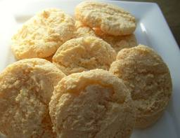
Coop. Extension Product Development
Advanced Food Science
Spring 2012
HSCI 345
Izell Rodriguez
“Same great taste, without the guilt”
Sweet Nothings

Mean Hedonic Scale:
 | P1 | 2’s | 3’s | 4’s | 5’s | 6 | 7 | Mean
Appearance | 5 | 4 | 5 | 4 | 4 | 4 | 4 | 4.2857142
Texture | 4 | 3 | 4 | 4 | 4 | 3 | 2 | 3.2857142
Sweetness | 5 | 4 | 5 | 4 | 3 | 5 | 1 | 3.8571428

Standard Deviation:
Appearance | 0.4879500
Texture | 0.7559289
Sweetness | 1.4638501

Graph of taste panel results:

Nutrient Analysis:
Per Amount from Recipe | Total Calories | Carbohydrate | Protein | Fat
Flour (3/4 cup) | 341 | 71.54 | 9.68 | 0.92
Baking Powder ( 1 tsp.) | 1 | 0.64 | 0 | 0
Salt (1/16 tsp.) | 0 | 0 | 0 | 0
Sugar (1/2 cup) | 387 | 99.98 | 0 | 0
Applesauce (1/8 cup) | 13 | 3.44 | 0.05 | 0.03
Egg White (1 egg) | 17 | 0.24 | 3.6 | 0.06
Vanilla extracts (1/4 tsp.) | 1 | 0.15 | 0 | 0
Total | 760 | 175.99 | 13.33 | 1.01

Amounts from USDA website: http://ndb.nal.usda.gov/ndb/foods/list

100 Kcal Nutrient Analysis
Serving Size | 1 cookie
Total Calories (cal) | 95
Carbohydrates (cal) | 22
Protein (cal) | 1.6
Fat(cal) | 0.12

